
Holy Cross College

Semester 2 Examination 2019

Question/Answer Booklet

Year 10 Science
Please place your student identification label in this box
(Extension)
Physics

Student Name
Student’s Teacher

Time allowed for this paper

Reading time before commencing work: 10 minutes
Working time for paper: 40 minutes

Materials required/recommended for this paper

To be provided by the supervisor

This Question/Answer Booklet
Data Sheet

To be provided by the candidate

Standard items: pens, pencils, eraser, correction fluid, ruler, highlighters.
Special items: non-programmable calculators satisfying the conditions set by the School Curriculum and Standards Authority for this course.

Important note to candidates

No other items may be taken into the examination room. It is your responsibility to ensure that you do not have any unauthorised notes or other items of a non-personal nature in the examination room. If you have any unauthorised material with you, hand it to the supervisor before reading any further.

Structure of this paper

Section | Number of questions available | Number of questions to be answered | Suggested working time  (minutes) | Marks available | Percentage of exam
Section One:  Multiple Choice | 24 | 24 | 15 | 24
Section Two:  Short Answer | 10 | 10 | 25 | 56
Section Three:
Comprehension
 |  |  |  | 80

Instructions to candidates

1. The rules for the conduct of examinations at Holy Cross College are detailed in the College Examination Policy. Sitting this examination implies that you agree to abide by these rules.

2. Write your answers in this Question/Answer Booklet.

3. Working or reasoning should be clearly shown when calculating or estimating answers.

4. You must be careful to confine your responses to the specific questions asked and to follow any instructions that are specific to a particular question.

5. Spare pages are included at the end of this booklet. They can be used for planning your responses and/or as additional space if required to continue an answer.

• Planning: If you use the spare pages for planning, indicate this clearly at the top of the page.
• Continuing an answer: If you need to use the space to continue an answer, indicate in the original answer space where the answer is continued, i.e. give the page number.
• Fill in the number of the question(s) that you are continuing to answer at the top of the page.

SECTION 1 MULTIPLE CHOICE (24 marks)

Make a choice of answer and mark it with a cross on the answer sheet provided.

1. Acceleration is defined as:

(a) the rate of change of speed.
(b) the rate of change of displacement.
(c) the rate of change of distance.
(d) the rate of change of velocity.

2. A decreasing rate of change of velocity could be called:

(a) positive acceleration.
(b) negative velocity.
(c) deceleration.
(d) braking.

3. In the absence of air resistance:

(a) heavier objects would accelerate toward the ground faster than lighter ones.
(b) more streamlined objects would accelerate toward the ground faster than less streamlined ones.
(c) all objects regardless of mass would accelerate toward the ground with the same velocity.
(d) objects with more mass would accelerate toward the ground faster than objects with less mass.

4. What is the acceleration of a car if it increases its velocity from 5.00 ms⁻¹ to 15.0 ms⁻¹ in
4.00 s?

(a) 2.50 ms⁻²
(b) 2.50 ms⁻¹
(c) 150 ms⁻²
(d) 5.20 ms⁻²

5. The diagram below shows the four forces acting on a van travelling along a straight, flat road. The forces are:

R = total resistance force; T = driving force; U = upward force of ground on van;
W = weight of van.
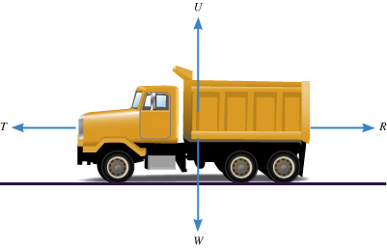
At one time, the van is speeding up (accelerating) in the forward direction. Which of the following best describes the forces at this time?

(a) U = W
(b) U = W; T < R
(c) U = W; T = R
(d) U = W; T > R
6. A balloon is inflated. When released, it rapidly speeds up. Which of the following best describes the force that causes the balloon’s motion?

(a) The push of the air in the room on the escaping air.
(b) The push of the escaping air on the air in the room.
(c) The push of the balloon on the escaping air.
(d) The push of the escaping air on the balloon.

7. You are watching a video of a passenger standing in a tram. Suddenly the passenger topples backwards. Which of the following best describes the motion of the tram at this moment?

(a) The tram starts moving forward.
(b) The tram starts moving backward.
(c) The tram is moving forwards and it starts to slow down.
(d) The tram is moving backwards and it starts to speed up.

8. Which of the following is NOT a true statement about your inertia?

(a) It tends to keep you stationary when a force acts on you.
(b) It is a force that keeps you moving at a constant speed.
(c) It tends to keep you moving in a straight line.
(d) It tends to resist any acceleration.

9. An object accelerates at 2.5 ms⁻² under a nett force of 20 N. What is the mass of the object?

(a) 0.25 kg
(b) 6.0 kg
(c) 8.0 kg
(d) 50 kg

10. A basketball player crouches down, and then stretches his legs to spring into the air. Which of the following best describes the size of the force of the ground on his feet while he is rising from the crouched position? (Note - he has not left the ground.)

(a) Greater than the force of his feet on the ground.
(b) Equal to the force of his feet on the ground.
(c) Equal to the weight of the player.
(d) Zero.

11. Which of the following is NOT a benefit of the ‘crumple zones’ of a vehicle during a crash?

(a) They increase the time taken to stop.
(b) They spread much of the energy of impact.
(c) They absorb much of the energy of impact.
(d) They reduce the risk of injury to any pedestrian struck by the vehicle.

12. An object starts from rest and accelerates at 5.0 ms⁻². After 4.0 seconds, its velocity will be:

(a) 0 ms⁻¹.
(b) 10 ms⁻¹.
(c) 20 ms⁻¹.
(d) 30 ms⁻¹.

13. The tendency of an object to resist changes in its motion is called:

(a) inertia.
(b) weight.
(c) friction.
(d) work.

14. Newton’s Law, known as the Law of Inertia, is:

(a) his first law.
(b) his second law.
(c) his third law.
(d) none of the above.

15. "If an object has zero acceleration, the object must be at rest." This statement is:

(a) always correct.
(b) sometimes correct.
(c) never correct.

16. An object is acted upon by a push force of 50 N forwards and a total frictional force of 40 N. The nett force will be:

(a) 10 N backwards
(b) 10 N forwards
(c) 90 N backwards
(d) 90 N forwards

17. The size of the acceleration acting on an object of mass 10.0 kg that has a nett force of 3.0 N acting on it will be:

(a) 13.0 ms⁻².
(b) 3.3 ms⁻².
(c) 0.3 ms⁻².
(d) 30.0 ms⁻².

18. A cyclist has a weight of 500 N, the road pushes up with 500 N, the push force forwards is
30 N and the friction opposing the motion is 32 N. The cyclist will be:

(a) stationary.
(b) accelerating.
(c) decelerating.
(d) travelling at constant velocity.

19. When you hit a tennis ball with a tennis racquet, the action force is the force of the racquet hitting the ball and the reaction force is:

(a) the ball hitting the racquet.
(b) the jarring force you feel through your hand.
(c) the weight force on the ball.
(d) the weight force on you.

20. Which of the following is NOT a significant benefit of air bags in a collision?

(a) They prevent collisions between occupants and the windscreen.
(b) They prevent collisions between the driver and the steering wheel.
(c) They protect occupants from whiplash injury in rear-end collisions.
(d) They cushion impacts between the occupant and the side of the vehicle.

21. Which of the following does NOT describe a benefit of using a seatbelt in a head-on crash?

(a) It stops the occupant from continuing to move forward when the vehicle stops.
(b) It reduces the risk of whiplash type injury.
(c) It stops the occupant at the same rate as the vehicle.
(d) It prevents the occupant from striking the windshield.

22. Find the final velocity of a cyclist travelling at 3.00 ms⁻¹ if she accelerates at 1.20 ms⁻² for
5.00 seconds.

(a) 9.00 ms⁻¹
(b) 19.0 ms⁻¹
(c) 99.0 ms⁻¹
(d) 0.900 ms⁻¹

23. An object has a mass of 250 kg . On Earth, it would have a weight closest to:

(a) 2.5 N.
(b) 25 N.
(c) 250 N.
(d) 2500 N.

24. A driver noticed that his speedo reading was 118.8 kmh⁻¹. Which of the following represents the speedo reading in ms⁻¹?

(a) 11880 ms⁻¹
(b) 33 ms⁻¹
(c) 118 ms⁻¹
(d) 330 ms⁻¹

END OF SECTION 1
SECTION 2 SHORT ANSWER (56 marks)

Attempt all questions. Write your answers in the spaces provided.

1. Vincent dropped a stone down a well and saw it hit the bottom 3.5 s later. Calculate the depth of the well, given the stone starts from rest.
(3 marks)

2. Susie decided to jump off a rock ledge 8.00 m high into Circular Pool in Karinjini National Park. What was Susie's impact velocity, assuming her initial vertical velocity was zero?
(3 marks)

3. Consider the forces acting on the car in the diagram below.

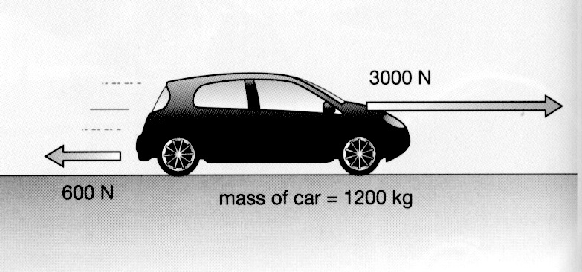

(a) Calculate the nett force acting on the car. (2 marks)

(b) Calculate the acceleration of the car. (3 marks)

4. Sean steps on the brake pedal of his car for 6.0 s. This applies a retarding force of 2100 N to slow his 750 kg car, which is travelling in an easterly direction at
95.0 kmh⁻¹.

(a) Calculate his car's deceleration. (3 marks)

(b) Does the car stop in this time? Justify your answer by doing a calculation.
(4 marks)

5. Max has a mass of 57 kg on Earth. He is lucky enough to be selected for a junior astronaut programme and journeys to the International Space Station (ISS) for a
3-month stay.

(a) Calculate Max's weight on Earth. (3 marks)

(b) Max "floats” in space within the ISS. Is he weightless? Explain your answer.
(2 marks)

(c) Is Max ever weightless in space? Explain your answer. (2 marks)

6. A mass of 28 kg is brought to rest by an average force of 98 N acting for 5.0 s.
Calculate the initial velocity of the mass. (4 marks)

7. A force of 36 N acts on a mass of 24 kg moving at 15 ms⁻¹, causing it to accelerate in a straight line. How far does it travel to reach 35 ms⁻¹?
(4 marks)

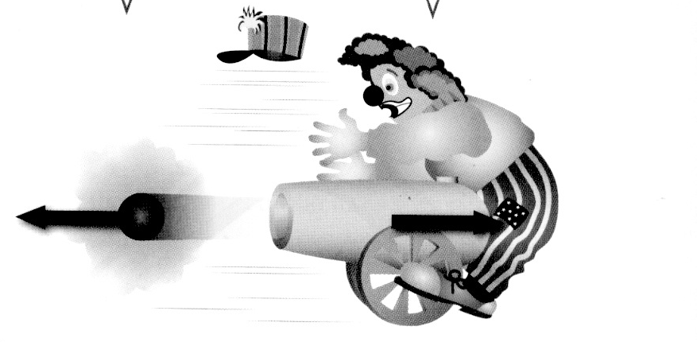
8. Look at the diagram showing a clown and a cannon at a circus.
(a) Which of Newton's three laws applies to this situation? (1 mark)

(b) Explain clearly why the cannon hits the clown. (2 marks)

9. At the 2016 Singapore Grand Prix, Daniel Ricciardo accelerates quickly from the start and reaches 285 kmh⁻¹ after 4.7 s. He is nearly at the first corner.

(a) Calculate the average acceleration of the car. (3 marks)

(b) Ricciardo is still travelling at 285 kmh⁻¹ when he has to brake strongly to reduce the speed of the car to 110 kmh⁻¹ to make it around the first corner. Given that the mass of the car is 780 kg and it takes 1.2 s to slow the car, calculate:

(i) the deceleration of the car. (3 marks)

(ii) the average force exerted by the brakes. (3 marks)

(c) At the start of the race, a car was hit and sent sideways into the rubber tyre wall, which acts as a safety device to protect the drivers.

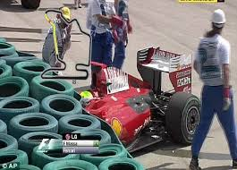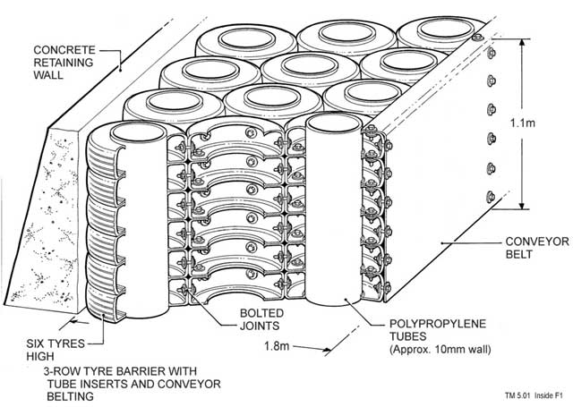

(i) Explain the Physics principle behind how the tyre wall acts as a safety barrier to protect the driver.
(2 marks)

(ii) Tyre walls are around every corner on the track. When a car loses grip and starts to slide, it goes off the track in a straight line, even if it is skidding sideways.

Which of Newton's three laws applies to this situation? (1 mark)

Explain clearly why this happens. (2 marks)

10. After winning the Wimbledon tennis final this year, Novak Djokavic hit a tennis ball vertically at 25.0 ms⁻¹ in celebration. It was blown sideways by the wind and caught by a girl in the stands who was sitting 15.0 m vertically above where the ball was hit. Ignore any sideways movement and air resistance in your calculations.

(a) How high did the ball rise? (3 marks)

(b) What was the velocity of the ball when the girl caught it? (3 marks)

END OF EXAMINATION
ADDITIONAL WORKING SPACE

